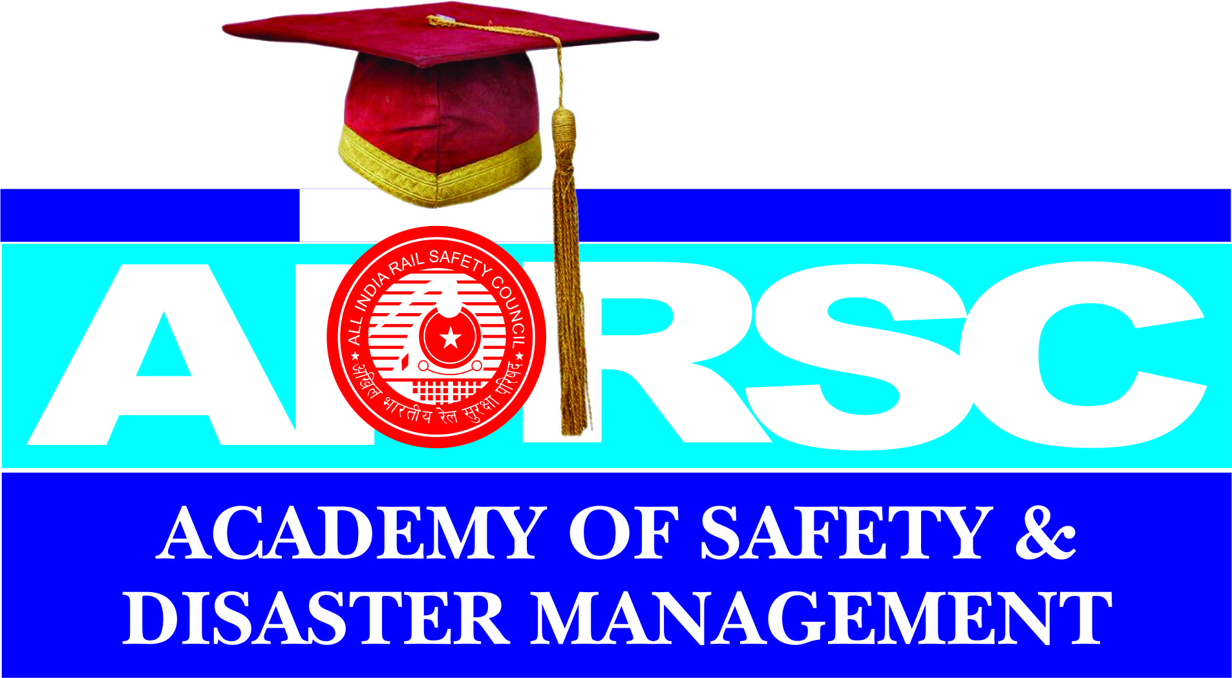
ADMISSION PROCESS
Eligibility Criteria for Admission & Instructions
COURSE OFFERD
MBA ( SAFETY MANAGEMENT )
Duration : TWO YEARS Mode : REGULAR
Admission Qualification:
A Candidate who has passed a three year Bachelor Degree from a recognized University or equivalent degree with a minimum of 50% in aggregate or who has passed Bachelor Degree with less than 50% but
has three years work experience as management / supervisor or as a professional.
Programme Duration:
The Programme Duration for MBA will be two years comprising of four semesters, but the candidate will have to complete the programme with in four years from the session of enrollment.

MBA ( DISASTER MANAGEMENT )
Duration : TWO YEARS Mode : REGULAR
Admission Qualification:
A Candidate who has passed a three year Bachelor Degree from a recognized University or equivalent degree with a minimum of 50% in aggregate or who has passed Bachelor Degree with less than 50% but has three years work experience as management / supervisor or as a professional.
Programme Duration:
The Programme Duration for MBA will be two years comprising of four semesters, but the candidate will have to complete the programme with in four years from the session of enrollment.

B.Tech ( Safety Engineering)
Duration : TWO YEARS Mode : REGULAR
Admission Qualification: +2 ( Science)
The Cndidate who has B.Tech Degree, in Safety Engineering , will get abundant job opportunities in Indian Government Departments. All leading PSU’s are looking for such Technical and Safety Engineering Degree holders for immediate appointments. Multiple job opportunities are available in safety Engineering compared to other Engineering branches.

P.G. DIPLOMA IN SAFETY MANAGEMENT
Duration : ONE YEAR Mode : REGULAR
Admission Qualification:
A Candidate who has passed a three year Bachelor Degree from a recognized University or equivalent degree.
It is a job oriented Course, therefore, hands on experience will be proved and abundant job opportunities in Government Sectors and PSU’s in India and in Industries abroad will be made available.

DIPLOMA IN SAFETY MANAGEMENT
Duration : TWO YEARS Mode : REGULAR
Admission Qualification: 10th, +2, ITI (NCVT)
The Candidate who has passed Diploma in Safety Management , will get abundant job Opportunities in Indian Government Departments. All Leading PSU’s are looking for such Technical and Safety Management Diploma holders for immediate appointments. Multiple job opportunities are available for Diploma holders in Safety Management compared to other Polytechnic diploma holders.

Admission Procedure:

- Last date of receipt of filled application will be with in 15 days after the publication of results in the qualifying examination.
- After the last date of receipt at the application, a rank list will be prepared based on the marks obtained by the candidates in the qualifying examination.
- This rank list will be published in the website on the 7th day after the last day of receipt at the application.
- Last date at admission will be indicated with the rank list (or) adequate time will be given for admission.

Lapsed Seats:
- If there is any lapsed seat, it will be filled from the wait – listed Candidates.
- Application can also be down loaded from the AASDM’s Website.

Instructions to Applicants:
Important Instructions to Students and Parents before filling up application and other forms for admission on:

- Students / Parents are expected to read and understand thoroughly the sections of this information brochure.
- Fees once paid are not refundable. The Students are liable to pay the fees for the entire Course on the due dates. Parents / Students are advised to take note of this before applying for courses.
- The information brochure is given with only –one set of forms for admission.
- The Student should till up the following forms.
- Application Form for Admission.
- Student Personal Record Form ; The Affidavit in Regional Language and English on the back of this form is to be signed by the student and Parent / Guardian.
- Hostel Accommodation Application Form if Available this facility in center.
- Transport Application Form .C. if Available this facility in center.

5. Suggested tips for completing application.
- Read the information brochure more than once.
- Confirm the eligibility criteria for various courses.
- Choose the course carefully.
- Keep latest photographs and copies at certificates – Pasted in the Application Form.
- Application Forms shall be submitted with :
- All Details Filled – in
- Photographs pasted in all forms / cards.
- The photographs and signatures of authorized – visitors on the application form.
- The affidavit signed in English or own Language.
- Two sets of attested Xerox copies at Certificates and other documents.

Cost of Application
MBA Safety Management - 500/-
MBA Disaster Management - 500/-
B.Tech Safety Engineering - 400/-
P.G. Dip., Safety Management- 300/-
Dip., Safety Management - 300/-

Applications:
Applications forms are available at any of our AIRSC ACADEMY OF SAFETY AND Disaster MANAGEMENT ,CENTER Officers located at various places.
- Or by E.mailing a request: admission @ airsc.in
- Or by down loading from the website: www.airsc.in
- For Admissions plus contact all our AASDM Center Co- Ordinators.

Note: All payment should be paid in the form of Demand Draft from any Nationalized Bank in favour of “ALL INDIA RAIL SAFEY COUNCIL” Payable at NEW DELHI. Applicants who have downloaded the applications shall have to pay 5/- in addition. Application Seeking applications by post will have to pay an additional RS.50/-

For More Information
AIRSC ACADEMY OF SAFETY AND Disaster MANAGEMENT

OUR CAMPUS

For Our AASDM Center Details Visit Center Gallery

